Morgan Faith Keane Memorial Scholarship
“Mo’ Kindness Project”
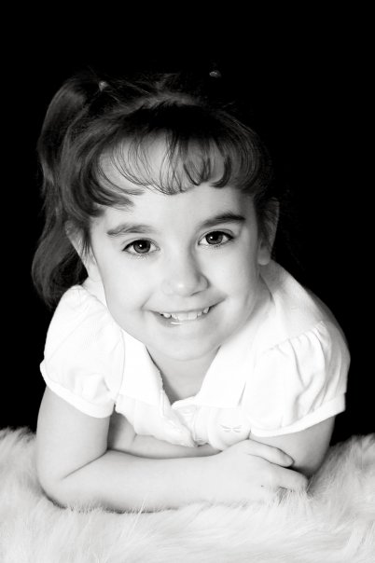

Morgan Faith Keane attended school at Orofino Elementary. In 2012, Morgan was a third grader when she lost her battle to a rare condition known as Ivemark’s Syndrome. She fought bravely through 4 open heart surgeries, 1 large exploratory surgery and over 20 minor surgeries. She spent a large amount of her nearly 9 years of life in and out of hospitals. Through it all, she wore a smile of bravery and a shield of strength like no other but above all was kind to everyone she meant.

When Morgan began kindergarten, we started this scholarship program to “pay it forward” to the people of Orofino that so generously reached out to offer support in our most difficult times. The year she died, her family decided it would only continue until her senior year and end with the Orofino Class of 2021.

The only two requirements are: that you intend to further your education at a college, university, vocation, trade school or military and that you intend to bring “Mo’ Kindness” to the world.

You must either type or print all your answers neatly in ink.
Application responses must be sent to:
Angie Stegner, 1002 Burrell Ave., Lewiston, Idaho 83501 and postmarked by 5/15/2020.

- Name: ______________________________________________________________

- Address: ___________________________________________________________

_____________________________________________________________

- Applicant must register at a college, university, vocation or trade school

1st School Choice: ______________________________________________

2nd School Choice: ______________________________________________

3rd School Choice: ______________________________________________

- Personal Essay: Please submit a one page essay telling us of a time that you were faced with a difficult situation and were able to overcome it with strength and bravery. Include your future plans and why this scholarship would benefit you.

- Letter of Recommendation: Please provide one letter of recommendation from whomever you choose that will testify your “Mo’ Kindness Spirit” and that you share some of the same character traits of strength, bravery, and kindness that Morgan did.
.

Signature _______________________________________ Date _________________________

